How many types of volume an instance can have?

**EBS** – Elastic Block Store and **root**

Root volume is the default volume.

Generally, Operating system will be loaded into the root volume.

EBS volume is for additional storage purpose.

**EC2 Dashboard – Region specific**

Multinational clients will have multiple infrastructure in multiple countries.

Let’s say we have to connect to Singapore region from Mumbai region.

The instance which is present in Mumbai region will not be present in Singapore region.

Every region is independent.

For example:

We have two volumes, one volume in Mumbai region (demo) and one in Singapore region (machine1).

Mumbai region Demo with two volumes. ( Root and EBS )

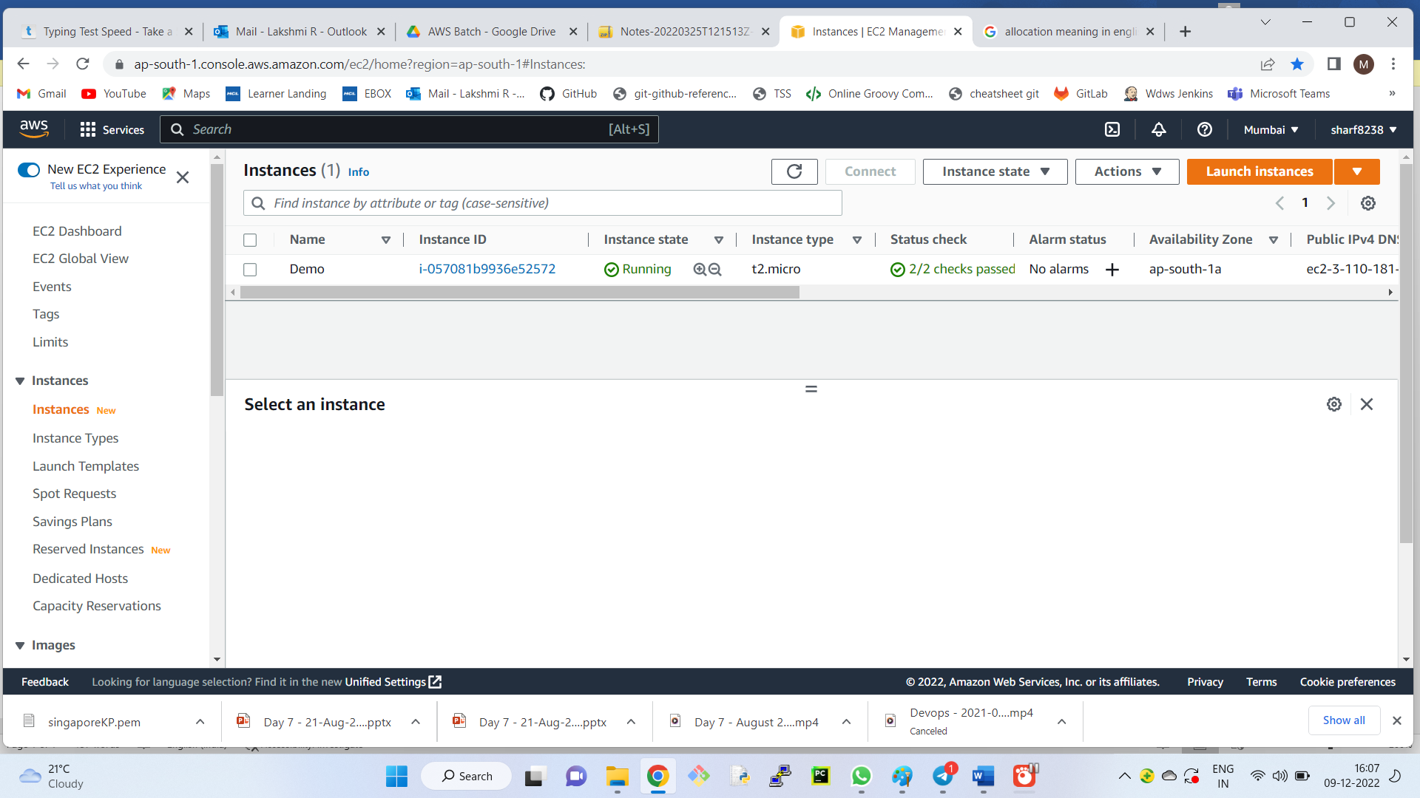

Singapore region machine1 with single volume.

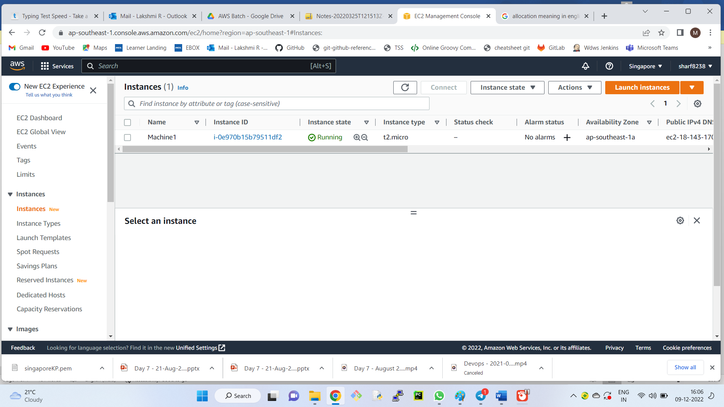

Now client requirement is to replicate the EBS volume which is present in Mumbai to Singapore.

We cannot directly move the volumes.

Solution:

Mumbai region

**Step -1:** Convert the volume to snapshots.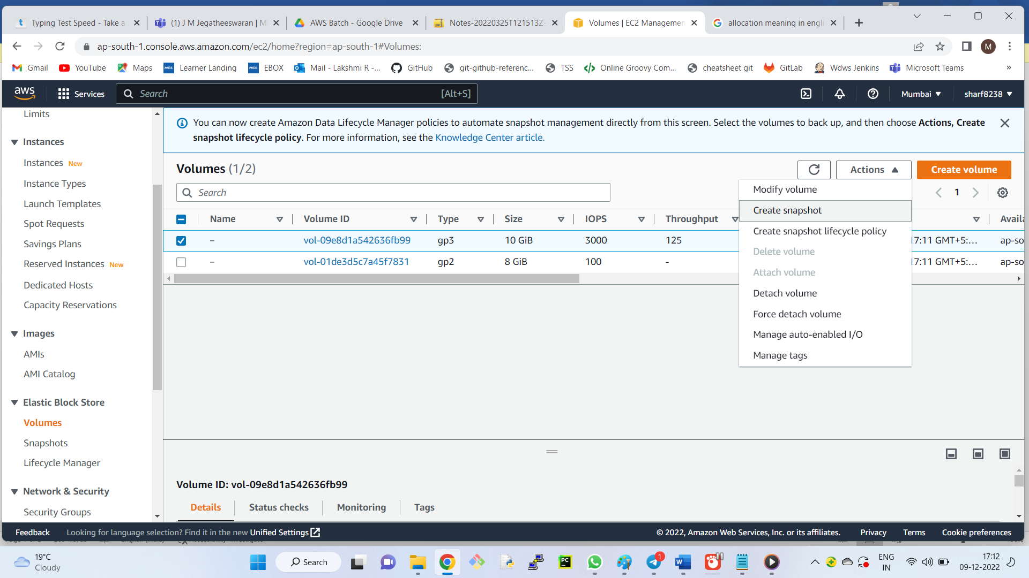

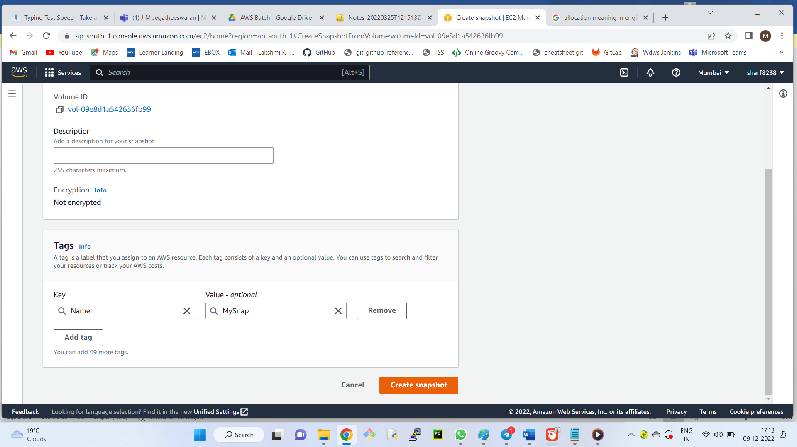

**Step – 2:** Copy the snapshot from Mumbai region to Singapore region.

Actions – Copy Snapshot – Mention the destination – Copy Snapshot

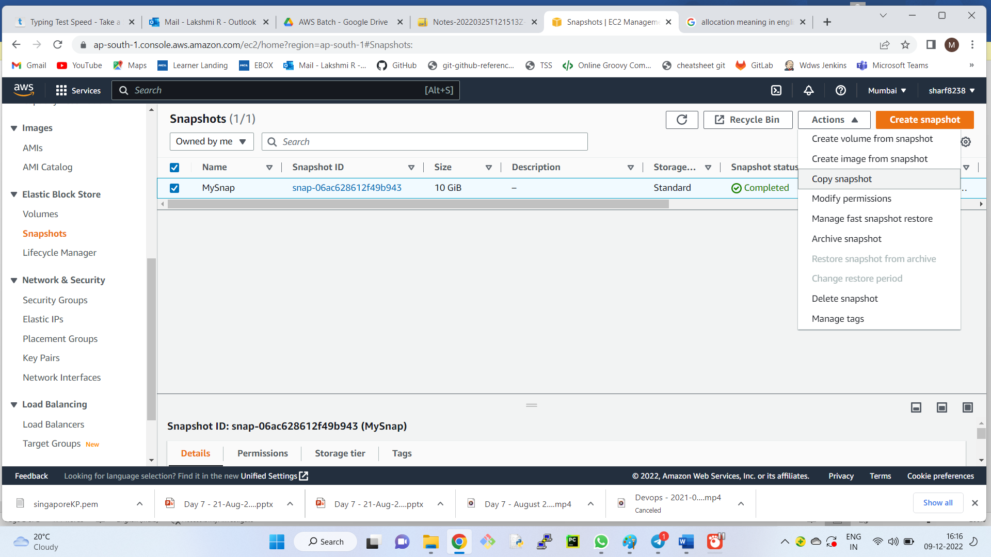

Note the availability zone of macine1 in Singapore (ap-southeast-1a)

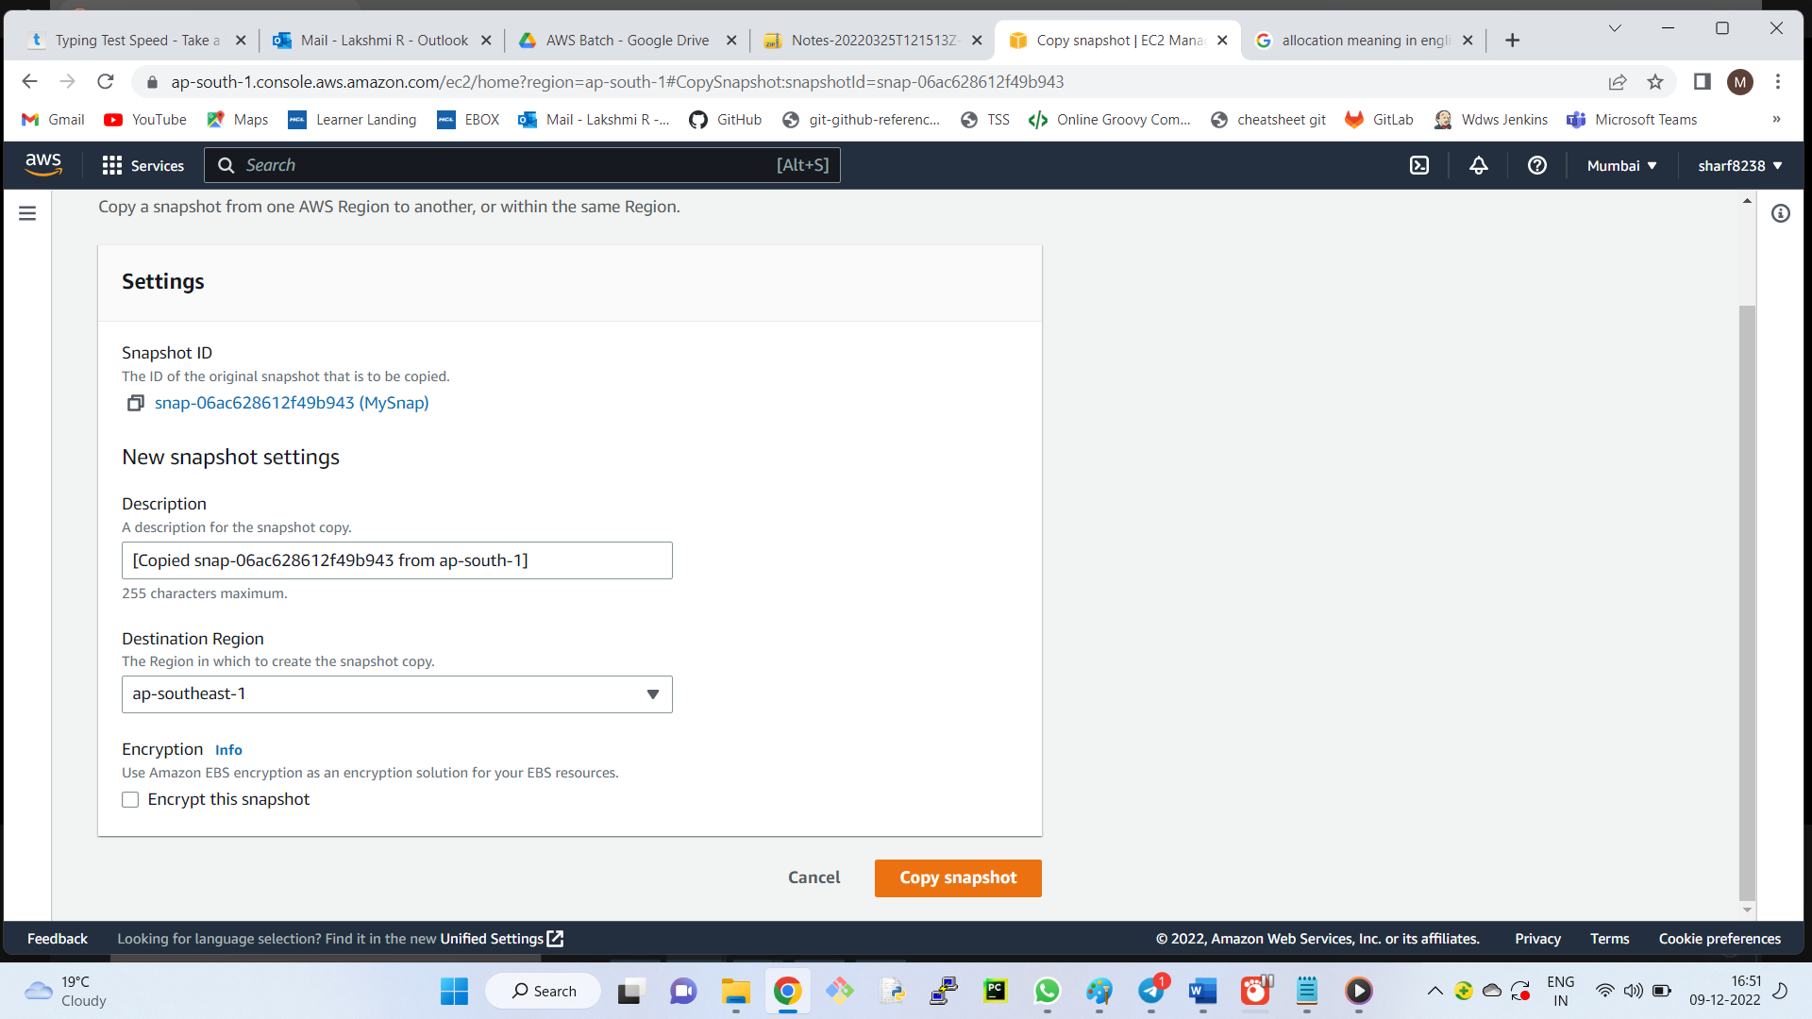

Switch to Singapore region.

**Step – 3:** Convert snap to volume and attach it.

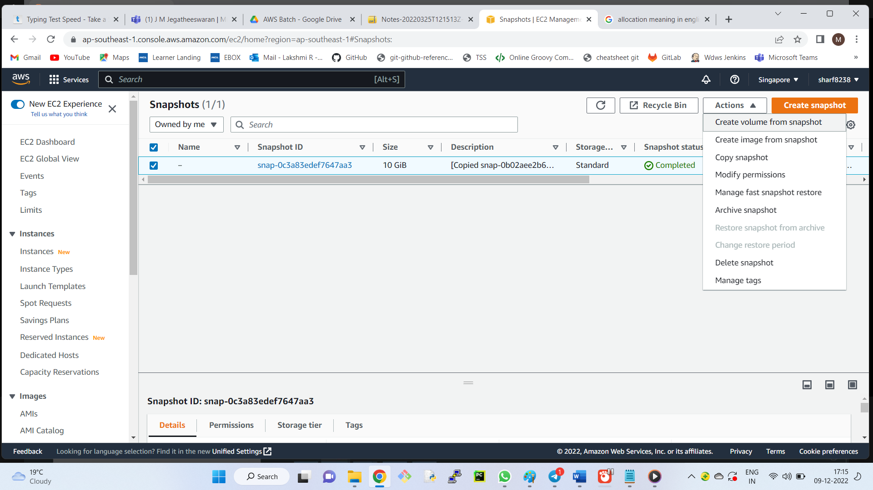

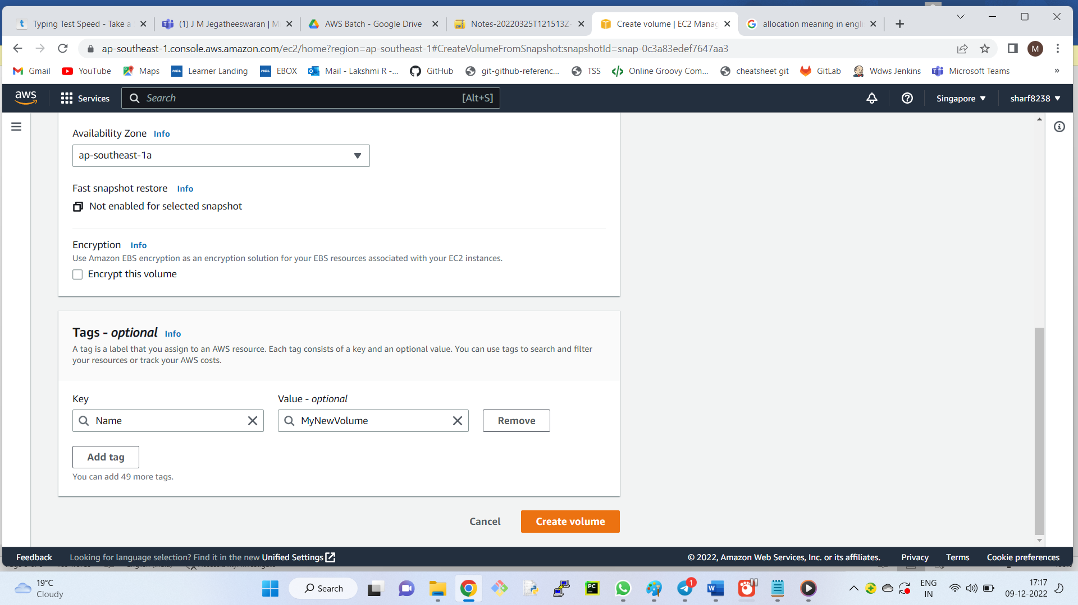

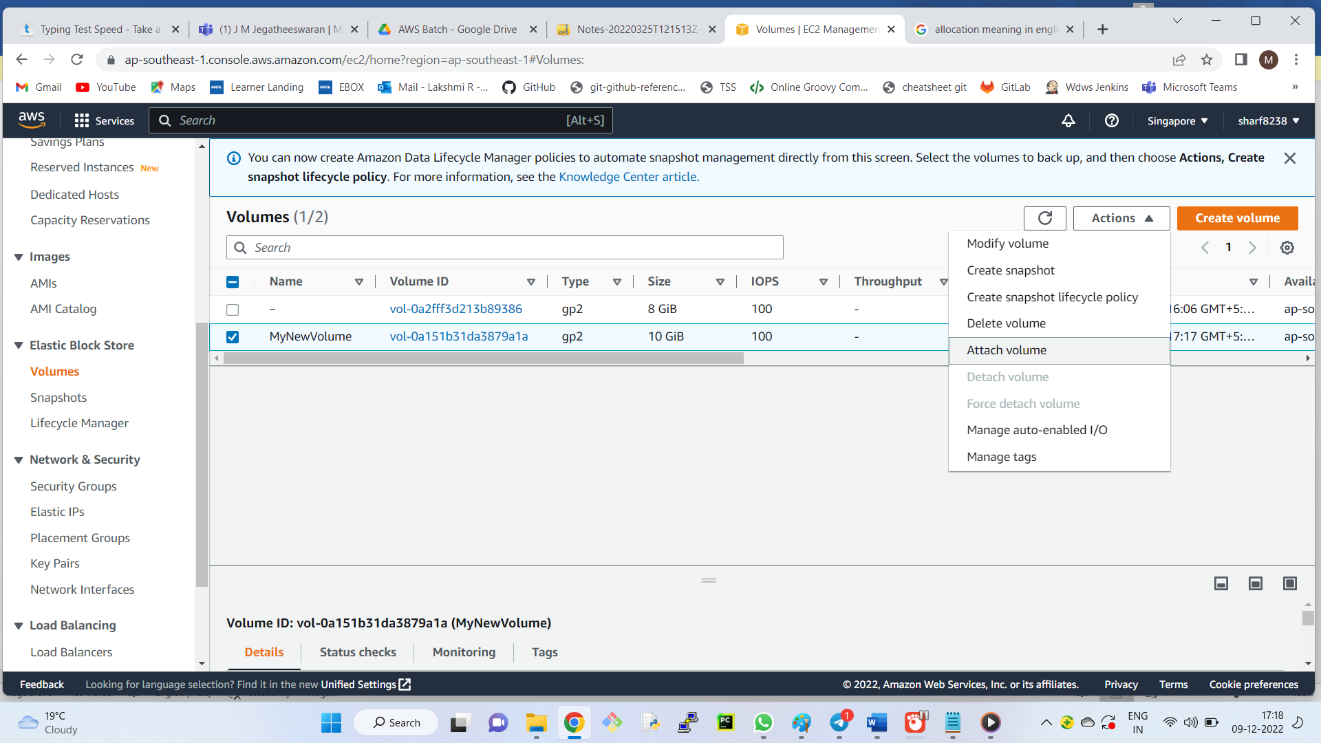

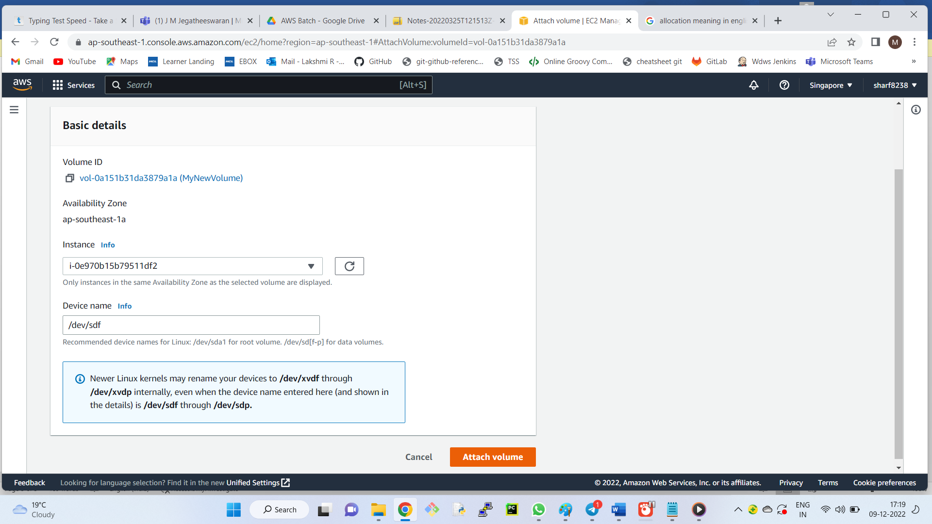

Hurray! We successfully attached EBS volume from Mumbai region to Singapore region.

Snapshots is the copy of volume. AMI is copy of complete instance and AMI refers to the copy of root volume.

**Creating Customized API**

Let’s say we have a demo instance with some n number of software installed in Mumbai region.

Client requirement is to replicate the complete instance with the same set of configurations and software in the Singapore region also.

Solution:

To replicate the instance, we can create the image of the instance.

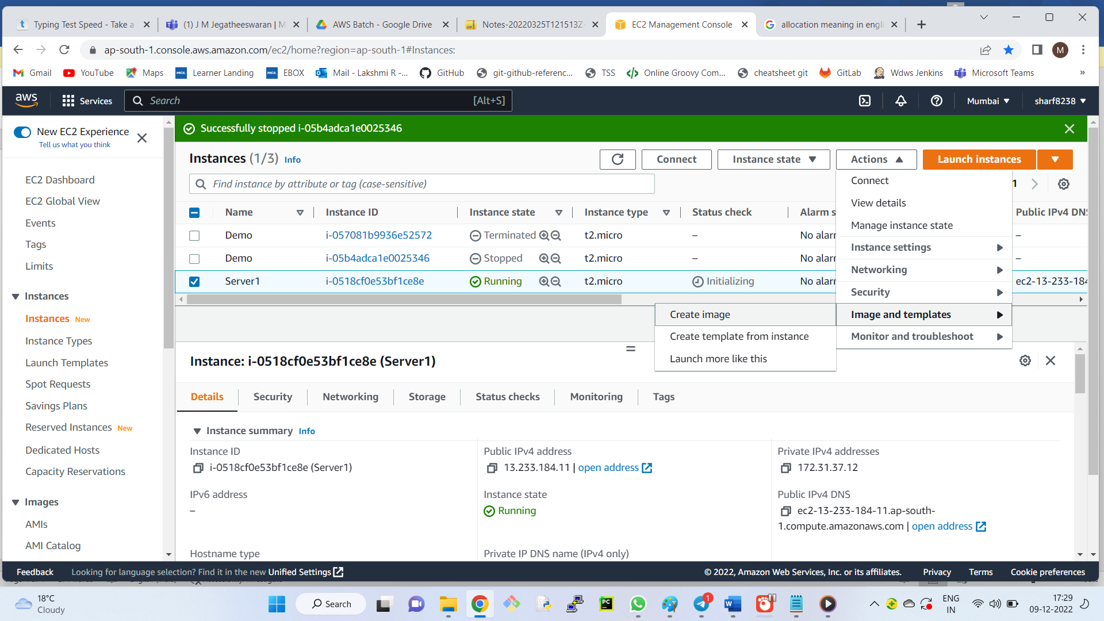

Declare the image name as MyIMG and click on create image.

Images – AMIs – Name it as MyAMI

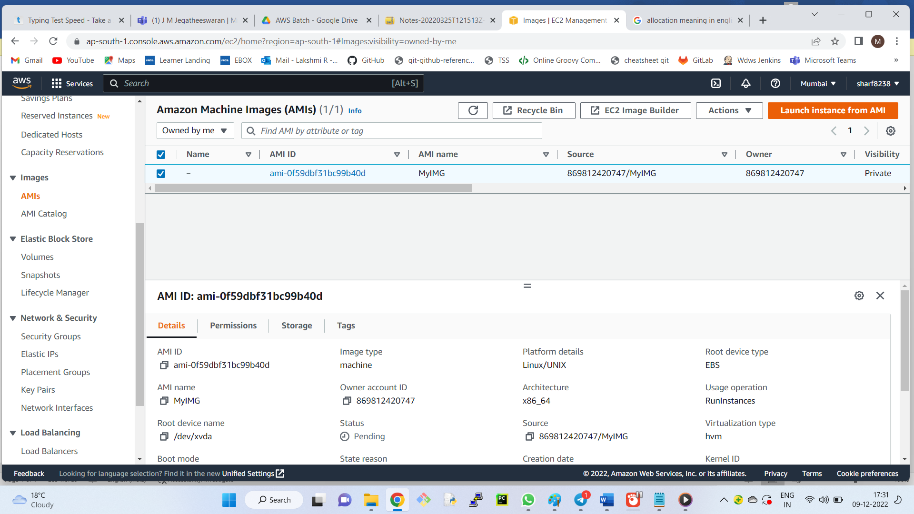

Instances – Launch instance – select MyAMIs -- MyIMG – Create keypair -- Launch

Scroll down and select My AMIs -- MyIMG – Launch instance – The instance will be created in same region.

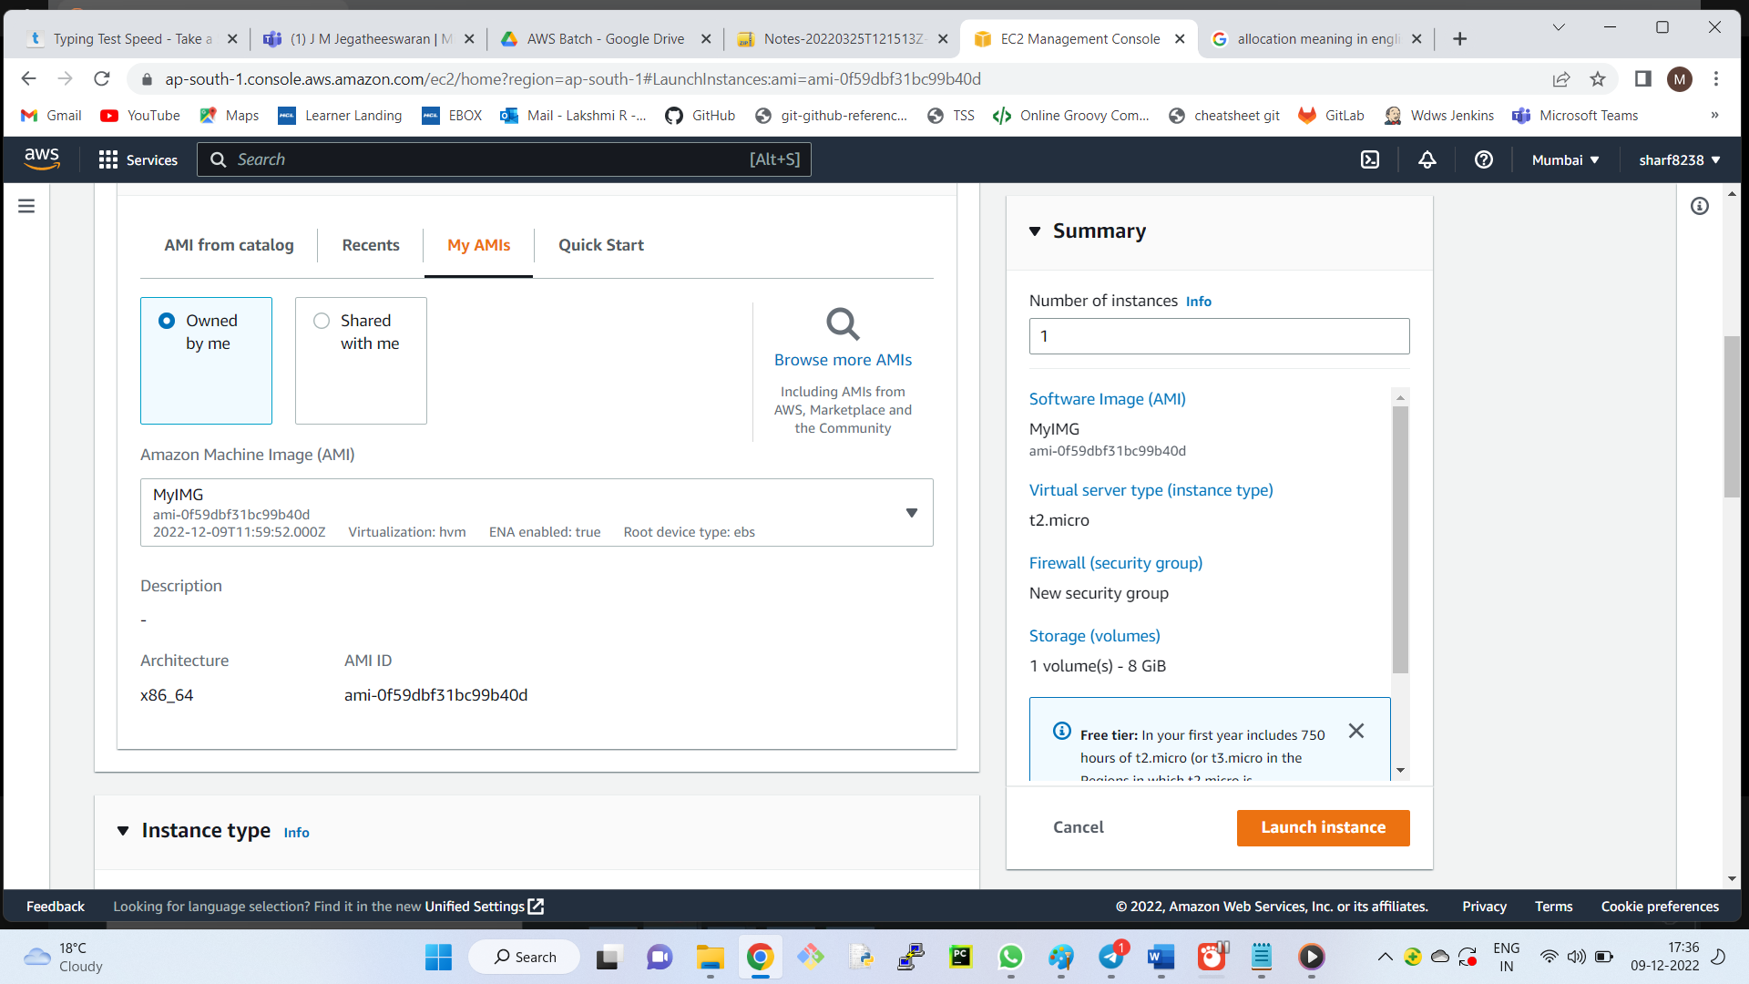

Now we have to copy the ami from mumbai to singapore region.

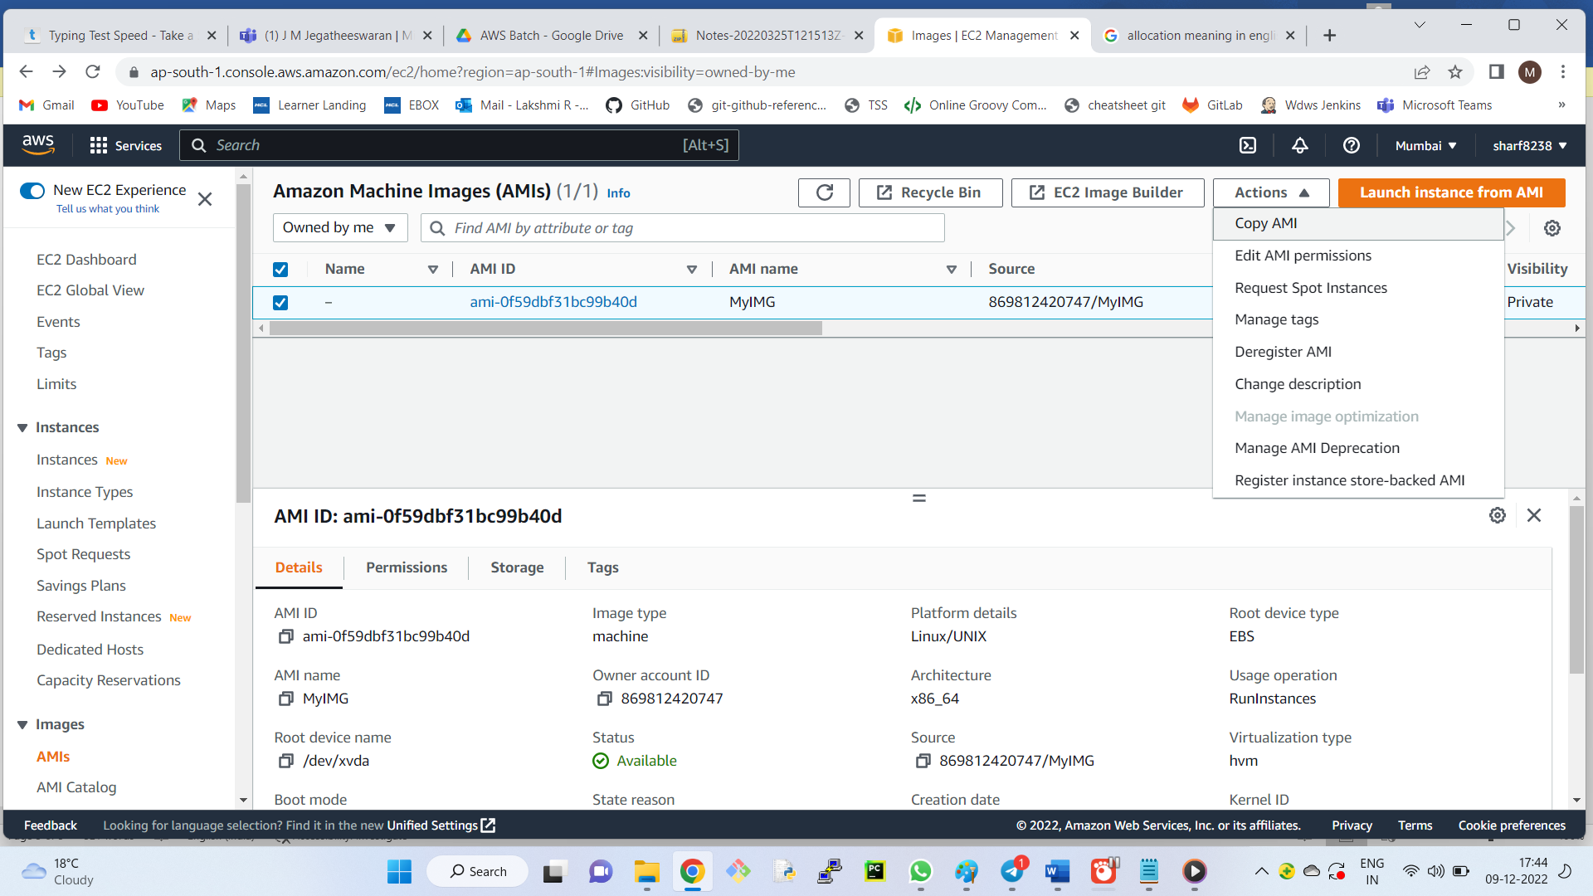

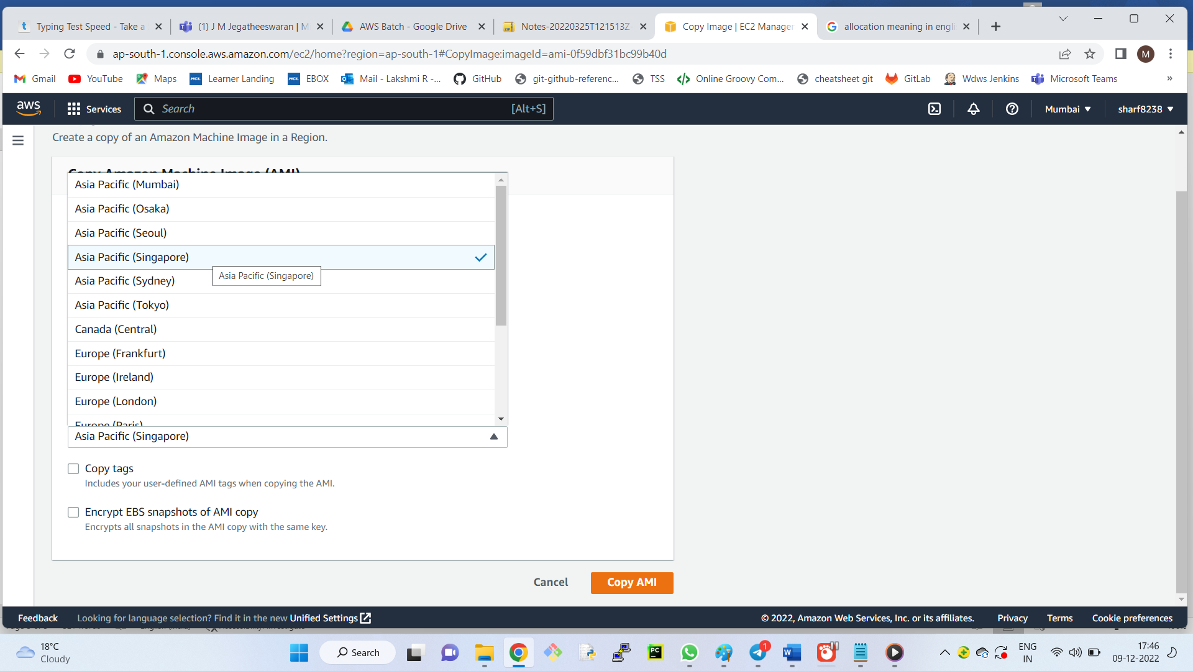

Switch to Singapore region.

AMI – name it as myami

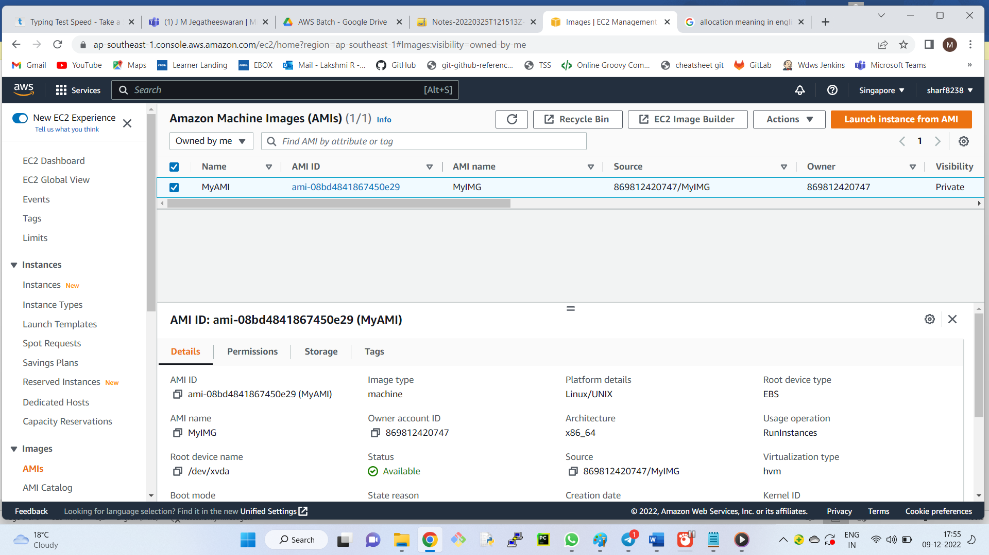

Go to instances – launch instances – select MyAMIs – MyIMG – Select keypair and launch it.

Notice now new instance will be added.

